Ronald Lakin
Sandra Ruiz
CIS 101
12 October 2015
Comparing Mobile Operating Systems
When choosing a new smart phone or tablet it is important to compare the device’s mobile operating system. A mobile operating system, also called a mobile OS, is the system software that is specifically designed to run on mobile devices such as mobile phones, smartphones, PDAs, tablet computers and other handheld devices (Beal). Early smart phones were expensive, used physical keyboards, and contained email, calendar, spreadsheet, and other software apps aimed at the business professional. It wasn’t until 2007 when Apple introduced the IPhone that mobile devices combined powerful multimedia functions with the same email and web browsing features designed for the average consumer (Martin)
The most popular mobile operating systems today are IOS, Android OS, and Windows Phone (see figure 1).

Figure 1 Smartphone/Tablet Market Share 2015 Q2 (Net Market Share)
All of these operating systems offer similar features including onscreen keyboards, colorful user interfaces, pre-loaded applications, video streaming, internet and email. Software applications called apps can be downloaded through each company’s app store. At the moment there are around four million apps available for purchase, many for free (see fig. 2).

Figure 2 App Availability Chart (Statista)
While any of these mobile operating systems would do an excellent job, there are other factors to consider before making a decision.
- Is it easy to use and navigate?
- Can the user interface be customized?
- How many models are there to choose from?
- Are there plenty of apps to choose from?
- Are the applications reliable and secure?
Answering these questions will help you choose a mobile device best suited for your particular needs.
Apple’s mobile operating system IOS is considered a closed source operating system. This means the system software is locked and controlled by Apple. Developers use tools to write apps which must be approved by Apple before being released (Nakulas). This makes their system and apps very uniform, reliable and secure. Since Apple manufactures all of the devices running on IOS software, there are only a few models to choose from. Apple’s user interface is the easiest to learn and navigate, but allows very little customization. The ITunes App Store is easy to navigate and offers over 1.5 million apps for purchase. The current version is IOS 9 (see fig. 2).
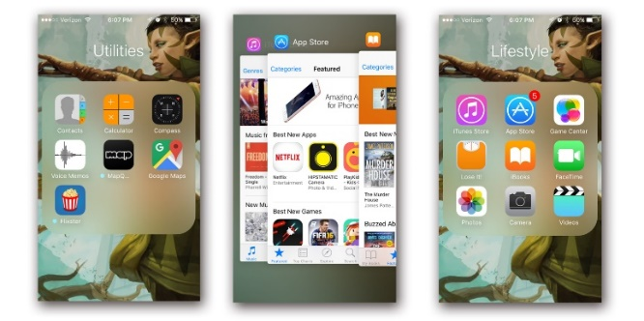
Figure 3 Apple IOS 9 Screenshots
Android OS, owned by Google, is an open source operating system that allows developers to control most functions and features of the software (Nakulas). While this makes it the most customizable on the market, the user interface is a little harder to learn and navigate. Android uses widgets to display live content on the screen as well as standard apps (Karch). There are plenty of devices to choose from, as most mobile device manufactures offer models using Android OS, even developing custom Android OS software for their products. The Google Play store has the largest selection of free and paid apps. One drawback to open source software is that without uniform guidelines and control, third party developers can write poorly designed and less secure apps (Heruska). The current version is Lollipop (see fig. 4).
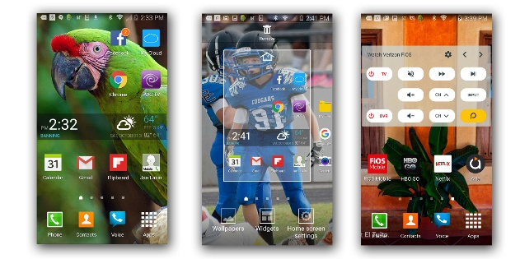
Figure 4 – Android OS Lollipop Screenshots
Microsoft announced it will be replacing the current Windows Phone 8.1 OS with Windows 10 Mobile in November (Boxall). Like Apple, Microsoft’s Windows Phone uses a closed source platform but offers more customization, and is very easy to learn and navigate. The user interface, called Metro, uses tiles for its app links that can be resized, repositioned, reshaped, and grouped together on the screen. Live tiles work like Widgets allowing live content to be displayed. Nokia is the leading manufacture to use Windows Phone in their mobile devices and offers a wide variety of models. The biggest drawback is the lack of Apps available for Windows Phone (see figure 2). Microsoft has announced that Windows 10 Mobile developers will be able to migrate Apple and Android Apps easily to the new platform (Warren). One nice feature is being able to sync and use Microsoft Office products on your device. The Current version is Windows Phone 8.1 (see fig. 4).
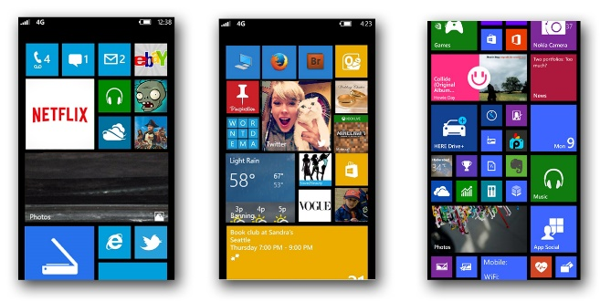
Figure 5 Windows Phone 8 and Windows 10 Mobile Screenshots
Apple’s IOS is the best choice for users who want a simple to operate, well designed and secure system with plenty of stylish apps available. If you are a power user who wants full control of the OS, a wide variety of models to choose from, and over 1.6 million apps to play with, then Android OS is your best option. Users that already have the newer Windows 8.1 or 10 on their PC can take advantage of Windows Phone’s nearly identical format. While the app selection is small, business minded users and students can make use of Microsoft Office apps and other productivity tools. The comparison chart below shows my 1st, 2nd and 3rd choices based on the features discussed (see Fig. 6).

Figure 6 Mobile OS Comparison Chart

Works Cited
Beal, Vangie. Mobile Operating Systems (Mobile OS) Explained. 10 August 2011. Web Document. 2 October 2015.
Boxall, Andy. New Windows 10 Mobile Technical Preview adds app store, universal Office, and more apps. 5 August 2015. Web Document. 30 September 2015.
Heruska, Joel. Google throws nearly a billion Android users under the bus, refuses to patch OS vulnerability. 12 January 2015. Web Document. 2 October 2015.
Karch, Marzia. Android Widget. n.d. Web Document. 30 September 2015.
Martin, Taylor. The Evolution of the Smart Phone. 28 July 2014. Web Post. 20 September 2015.
Nakulas, Angelos. What are the differences between iOS and Android testing? 13 October 2014. Web Document. 1 October 2015.
Net Market Share. Mobile/Tablet Operating System Market Share. n.d. Website Graph. 30 September 2015.
Statista. Number of apps available in leading app stores as of July 2015. n.d. Online web chart. 30 September 2015.
Vidal, Chris. Comparison between open and closed souce software. April 2013. Web Post. 30 September 2015.
Warren, Tom. Huge news: Windows 10 can run reworked Android and iOS apps. 29 April 2015. Web Document. 1 October 2015.

