Ronald Lakin

CIS 130 Hardware

Nick Romano

September 28 2015

Comparing Online Enterprise Backup Systems

A reliable online backup system is essential for any business running workstations and servers. Some things to consider when choosing an online backup solution are data security, data integrity, OS options, support, local backup options and the ability to meet your company’s RTOs[1] and RPOs[2]. The five enterprise online backup solutions being compared all have variable retention policies, central management consoles, 24-7 support, VM capabilities, and both local and cloud options.

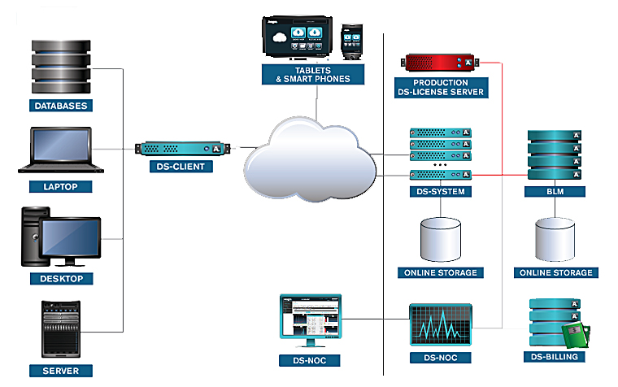

Figure 1- Asigra Cloud Backup Procedures (Asigra)

Asigra Cloud Backup requires no agents, which makes it easy to install and support. The software works with any platform including Windows, Linux or MAC environments, and supports servers, desktops, laptops, tablets, smartphones, virtual machines and cloud-based applications.

Backups are encrypted before sending to the cloud and remain encrypted once they reach their destination, using a decryption key held by the customer. Asigra’s agentless cloud backup uses a NIST approved FIPS 140-2 certified data center[3]. Asigra’s snapshots give you the ability to control Recovery Time Objectives and Recovery Point Objectives. The Asigra Snapshot Manager (included software) lets you easily configure, manage and schedule of backups and restores.

In case of disaster you can recover immediately from local machine failures by turning on a local backup VM copy and continue business operations. You can also convert critical physical machines into virtual copies and failover to a remote data center. In the event of a catastrophic site failure, normal business operations can continue, while you recover the local site (Asigra).

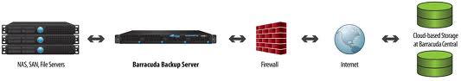

Figure 2 Barracuda Backup (Barracuda)

Barracuda Backups support Windows and Linux OS using their dedicated appliance server for local backup and then replication on the cloud. Barracuda Backup Server, is an appliance that enables centralized management of backup connections to multiple devices and provides the local storage necessary to keep a primary backup copy onsite for fast recovery. Data leaving the local appliance is encrypted in-flight and stored encrypted at rest with AES 256-bit.

Barracuda hosts seven data centers worldwide for fast replication and disaster recovery. The backup appliance uses a 256-bit encrypted VPN tunnel to send data. Data that is replicated to Barracuda’s cloud are stored twice on separate hardware for redundancy with an encryption key unique to the customer. Barracuda's Cloud to Cloud service allows customers to replicate data from supported cloud environments into Barracuda's Cloud Storage with options for long-term data retention and physical-to-virtual portability. Office 365 can also be back up for free the first year.

There are a wide range of restore options including bare metal restore and image restore for VMs. In case of disaster, Barracuda will ship an appliance prepopulated with the data in the cloud for fast local restores (Barracuda).

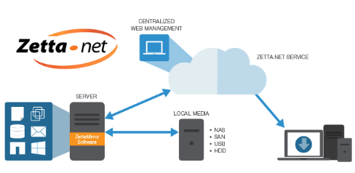

Figure 3-Zetta Backup Structure (Zetta.Net)

Zetta.Net. uses Zetta Data Protect software that includes a local backup, cloud backup, disaster recovery, and archiving. Its agentless software works on any Windows, Mac, and Linux platform and has plug-ins for SQL, MS Exchange, Hyper-V and VMware.

Zetta Mirror software is used to backup single files and directories, apps, or entire server images and save local backup copies to any local storage like NAS, hard drive, USB, etc. Zetta.Net cloud service offers high speed data transfer using built-in WAN optimization for rapid transfer of data over the Internet. Data is SSL encrypted in-flight and 256 bit encrypted at-rest and sent to SSAE16-audited data centers located in California and New Jersey.

You can recover your data in four ways. Because data is replicated in the cloud, the backup is mounted as a network drive for quick recovery. You can also recover data from locally or from a web browser remotely. In the event of disaster, data can be loaded on a hard drive and shipped to you (Zetta.Net).

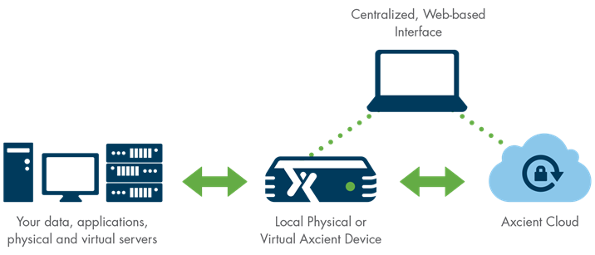

Figure 4 Axcient Backup (Axcient)

Axcient Enterprise backup supports Windows, Linux and VMware offering both local (dedicated HP Appliance) and/or Cloud (virtual appliance) Backups. Ancient’s agentless software uses Reverse Incremental backup and disaster recovery technology to create full recovery points that can be accessed, searched or restored from. You can quickly restore an old version of a file, or an entire system image. All devices on your network are identified by the software which then suggests protection profiles for your physical and virtual servers, workstations, and laptops.

Backups use AES encryption to protect your data both in transit and at rest in the data center. Axcient’s secure data centers have SSAE-16 and SOC2 certifications.

In case of disaster you can restore data locally or from the cloud, or restore an image to either bare metal or a virtual environment. Axcient allows you to create a virtual office so your business keeps running while you restore your system (Axcient).

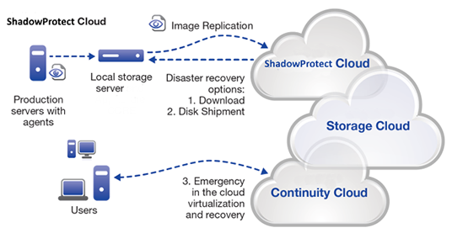

Figure 5- StorageCraft Disaster Recovery (StorageCraft)

StorageCraft combines its software suite with its cloud service for a secure and flexible backup solution. You can create local backups to NAS, SAS, USB, DVD, or Hard Drive and replicate to the StorageCraft Cloud.

Shadow ProtectServer software first creates backup image that includes data, operating system, applications, services, and configuration settings. From then on, all backups are incremental and can be taken as frequently as 15 minutes.

Storage Craft ImageManager consolidates the incremental backups into daily, weekly and monthly files which both reduces the length of the backup chain and allows you to administer your retention policies that meet your company’s RPOs. One of the most important features of the software is continual backup image verification. This safety feature insures your data is not corrupt before being replicated locally or to the cloud.

Storage Craft Cloud Services uses certified data centers in North America and Australia. Recovery options allow you to quickly restore single files or the entire system including Bare Metal restore and migration to a new environment locally or from the cloud. In case of disaster you can choose from 3 tiered recovery plan that best meets your company’s RTOs. You can have a drive with your image backup overnighted to, download from the web, or spin to a VM from any remote computer and run a virtual office instantly (StorageCraft).

All of the backup solutions compared would be an excellent choice for most businesses. While they all offer a variety of similar features and functions, StorageCraft’s flexibility and data integrity makes it the best choice. The ability to consolidate backups by day, week, month, etc. and set your own retention policies allows you to meet your Recovery Point Objectives. The most important factor in backups is data integrity. StorageCraft’s ImageManager verifies your data constantly, insuring backups are not corrupted before replicating locally or to the cloud. The disaster recovery options let you choose a plan that will meet your Recovery Time Objectives. StorageCraft designed the backup drivers used in their software which are also used by Norton Ghost, Symantec, and VMware.

**Executive Summary**

Asigra, Zetta.Net, Barracuda Backup, StorageCraft, and Axcient all have excellent online backup solutions with many similar features and functions.



**Key Feature**

**Axcient:** Multi-platform agentless system with local appliance/virtual option and plenty of restore choices.

**Barracuda:** Solid/Secure local appliance backup system with plenty of cloud services.

**Asigra:** Secure backup solution supporting all platforms with a wide choice of restore options.

**Zetta:** All in one software solution designed for speed with lots of options.

**Storage Craft:** Flexible, solid and secure backup solution for windows and Linux environments.

Works Cited

Asigra. *Asigra Home Page*. n.d. Web Page. 11 October 2015.

Axcient. *Backup & Disaster Recovery*. n.d. Web Page. 19 October 2015.

Barracuda. *Barracuda Backup Features* . n.d. Web Page. 12 October 2015.

StorageCraft. *StorageCraft Recover-Abilty*. n.d. Web Page. 22 October 2015.

Zetta.Net. *Zetta DataProtect*. n.d. Web Page. 20 October 2015.

1. Recovery Time Objective is how quickly you need your files restored.
2. Recovery Point Objective is how long you need to retain files.
3. Federal Information Processing Standard Security Requirements for Cryptographic Modules.